Note: This document is “view only”. Please create a copy of this document and save it to your drive.

**SOP- Archiving Client Project- Systems Vault**

**PREREQUISITES**

[SOP MASTER- Client Offboarding- Systems Vault](https://docs.google.com/document/d/1TUsxDcBOHWXnBeqWgS1kc_VazIBegKJf3Ob4nw4jYnk/edit?usp=sharing)

[Teamwork PM](https://sarahnoked.teamwork.com)

**PURPOSE**To archive projects in Teamwork that we are no longer using.

**POLICY**

Client projects are archived when a client is offboarded

Some clients have multiple projects with us, for example a launch project. Once the project is complete, the project is archived.

**PARTY**

Online Business Manager

**PROPERTY**

Online Business Manager

**PROCESS  
Part 1: Archive the project in Teamwork**

**PROCEDURE**

**Part 1: Archive the project in Teamwork**

1. Log-in to Teamwork. You should have the log-in information via lastpass. If you don’t, request this information from Sarah.
2. Navigate to the Project > Select the settings icon (top left) and click ‘Archive Project’

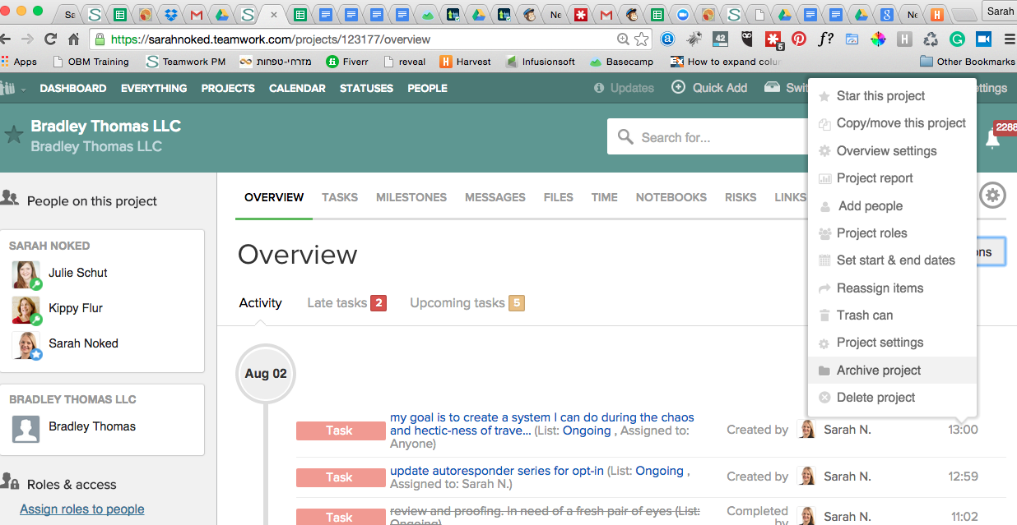

**Created by:**

**Department:** Delivery

**Date:**

**Revised:**

**Revised by:**